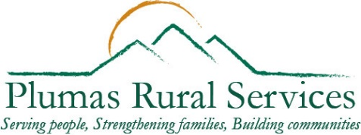
PLUMAS RURAL SERVICES

Domestic Violence Services
711 E. Main Street, Quincy CA 95971
Phone: (530) 283-5675, Fax: (530) 283-3647
dvs@plumasruralservices.org
Referring Agency

Agency: Click here to enter referring agency |  | Name: Click to enter your name
Phone: Click to enter number | FAX: Click to enter number |  | Email: Click to enter email
Does the client/patient know about this request? ☐ Yes ☐ No Is there a Release of Information ☐ Yes ☐ No

* Please attach release of information with this referral.
Referred Person Information

Name: Click or tap here to enter text. |  |  |  | DOB: mm/dd/yyyy
Address: Click here to enter text. |  | City: Click here to enter text. |  |  | Zip: Click to enter
Current living situation (e.g. homeless, with/without abuser): Click or tap here to enter text.
Are there children? ☐ Yes ☐ No if yes, do they live with referred person? ☐ Yes ☐ No
Do they have transportation? ☐ Yes ☐ No
Are they working with other agencies? ☐ Yes ☐ No if yes, please check all appropriate boxes below:
☐ Probation ☐ Family Court Services ☐ Behavioral Health ☐ Far Northern ☐ Social Services ☐ PCIRC ☐ AOD ☐ Child Support Services ☐ Veteran Services ☐ Victim Witness ☐ Sheriff’s Office ☐ Resource Center
☐ DA ☐ Other: Click or tap here to enter text.

Are there open cases involving the referred person (e.g. criminal, RO, child custody)? ☐ Yes ☐ No
If there is an active TRO/RO, is it against the referred person? ☐ Yes ☐ No
Reason for Referral
Check all that apply:

☐ Restraining Order ☐ Other legal ☐ Active Domestic Violence ☐ Past Domestic Violence ☐ Counseling
☐ Shelter ☐ Case Management ☐ Safety Planning ☐ Advocacy ☐ Information ☐ Other: Click or tap here to enter text.

Please describe areas checked above: Click or tap here to enter text.
Please give any additional information regarding situation: Click or tap here to enter text.
By signing below, I certify that the above mentioned information is given with permission by the referred person named in this document. All information is true and accurate to the best of my knowledge. I also understand that a referral does not guarantee eligibility of services through Plumas Rural Services, Domestic Violence Services. Determination of services will be made at the discretion of PRSDVS staff during the initial interview.

Signature of Referral Source: ________________________________________________ Date: ____________________
1/19/2022

